|  |
| --- |
| Circle Language Spec: Commands |

## Target Command Definition in a Diagram

The concept of target command definitions is explained in the article *Target Command Definition*. This article only explains its expression in a diagram.

To find the target definition, you first follow *all* the object redirections, then *one* class redirection, then *all* the object redirections and there it ends.

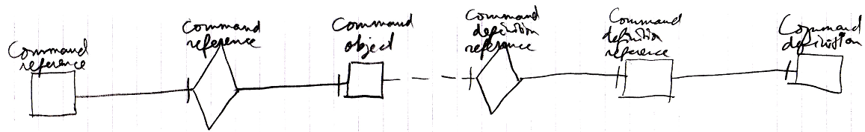

It does not matter if whether it is a diamond, that can be executed, or a square, that can not be executed.

If the definition has a definition as well, this does not redirect the original command object’s definition, because the second definition is *another* definition object, that the first definition is just *based* on. An object redirection is just a much tighter bond, than a class redirection.

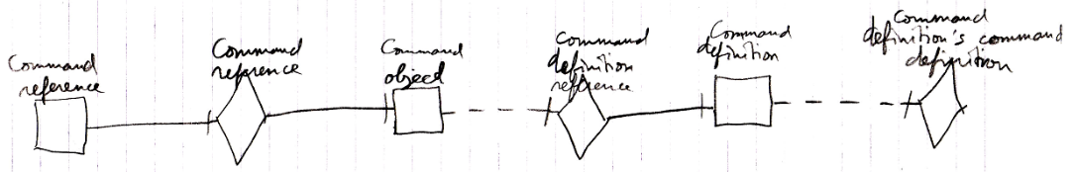

The target definition of the first object reference is the symbol Command Definition, not the symbol Command definition’s command definition. The same counts for the diagram below.

